**Habitat Suitability Scoring Curves**

Updated 16/07/2025 – ELW

Habitat suitability scoring curves are used to assess parameter values within the model area. Scores range from 0 (least suitable) to 1 (most suitable). To establish scoring curves, the shape of the curve relationship must first be determined. Second, curve fit should be decided based on points used to develop the curve. Along the curve, predetermined points are provided to relate the parameter value to the curve score. The points can either be known values and required to be represented in the curve (type “hard”) or can be estimated to help guide curve shape (type “soft”). An additional type “mid” option will include most provided points within the final curve.

**Curve Fit Types**

*Hard* – Points provided must be included in the curve output. The scoring line directly connects points based on the overall shape of the curve.

*Soft* – Points provided are used as estimates for parameter scoring and are not required to be included in the curve output. The scoring line of best fit is chosen for the curve based on the shape of the curve and the points provided. The maximum score (Y) value provided via points may not be included in the curve output.

*Mid* – Points provide may be included in curve output but are not required to be included. The scoring line will be fit closer to the points provided than the ‘soft’ fit but provide a smoother curve shape than the ‘hard’ fit.

**Curve Shapes**

Eight potential curve shapes are currently the options for developing habitat suitability score curves. Each continuous curve requires a minimum of 5 points for estimation. Curve names are used to describe the general shape of the curve, which can vary depending on the estimated points provided. Choose the curve shape closest to the desired output as a starting point then use the estimated points and fit type to tweak curve shape to match the desired output. In the following examples, the points provided to develop the curve are shown in red and the estimated parameter and score values are provided in the associated table. Hard fit lines are demonstrated by the dot-dash blue lines, soft fit lines by the dashed black lines, and mid fit lines by the solid orange line.

|  |  |
| --- | --- |
| Parameter Value | Suitability Score |
| 0 | 0 |
| 5 | 0.25 |
| 15 | 0.50 |
| 35 | 0.75 |
| 40 | 1 |

*Straight* – Straight linear line. Parameter values are entered for scores of 0, 0.25, 0.50, 0.75, and 1. Slope of the line can be either positive or negative based on how point values are entered.

|  |  |
| --- | --- |
| Parameter Value | Suitability Score |
| 0 | 0 |
| 0.5 | 0.05 |
| 1 | 0.50 |
| 1.5 | 0.95 |
| 40 | 1 |

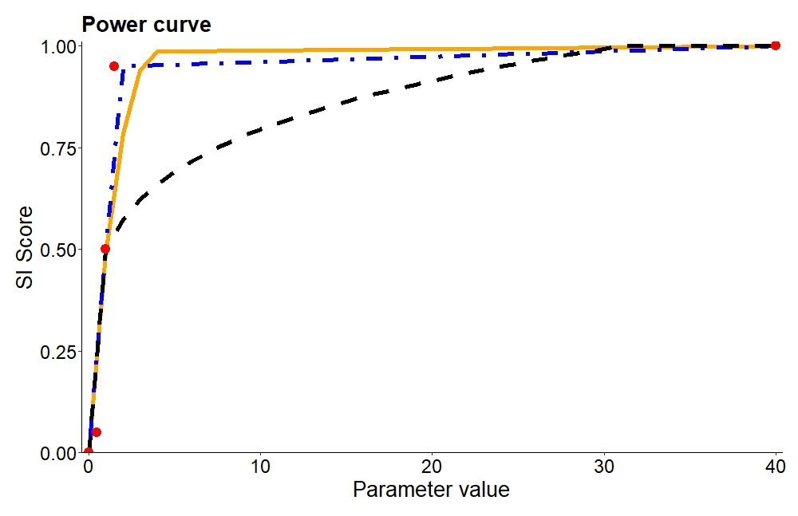*Power* – Curved line with a positive slope and the greatest change in suitability scores occurring at lower parameter values. Parameter values are entered for scores of 0, 0.05, 0.50, 0.95, and 1.

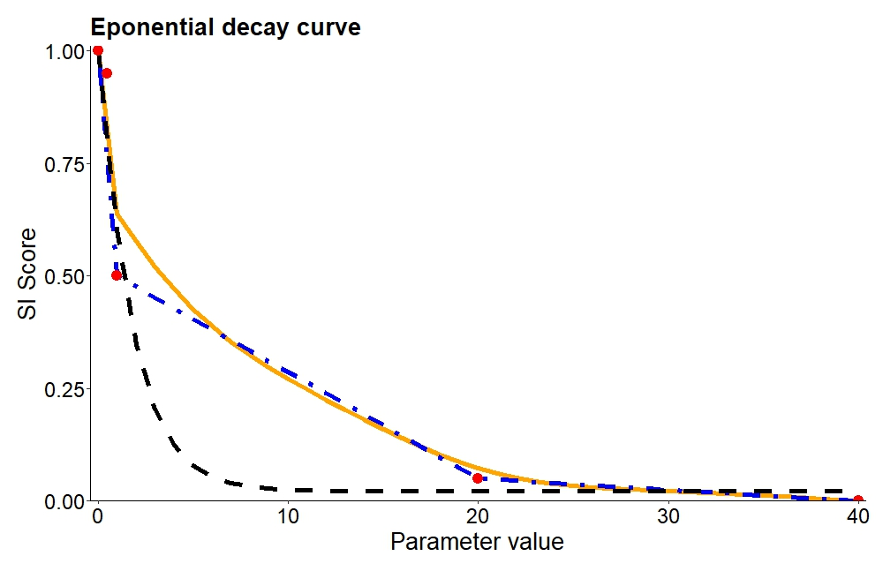*Exponential decay* – Curved line with a negative slope and the greatest change in suitability scores occurring at lower parameter values. Parameter values for 0 and 1 are not estimated but may be provided in the output of the model fit. Parameter values are entered for scores of 0.9999, 0.95, 0.50, 0.05, and 0.00001.

|  |  |
| --- | --- |
| Parameter Value | Suitability Score |
| 0.9999 | 0 |
| 0.95 | 0.5 |
| 0.50 | 1 |
| 0.05 | 1.5 |
| 0.00001 | 40 |

|  |  |
| --- | --- |
| Parameter Value | Suitability Score |
| 0 | 0 |
| 3 | 0.5 |
| 12 | 1 |
| 18 | 1 |
| 32 | 0.5 |
| 40 | 0 |

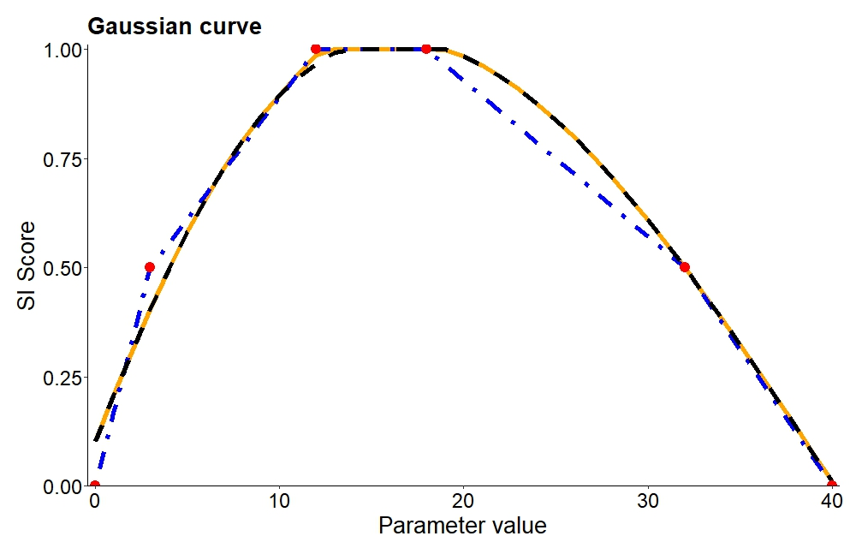*Gaussian* – A normal-shaped bell curve with the highest suitability scores occurring near the center of the specified limits and the lowest occurring at the limits. Parameter values are entered for 0, 0.5, 1, 1, 0.5, 0. Both parameter value end points of the maximum suitability score (1) may not be included in a soft fit line.

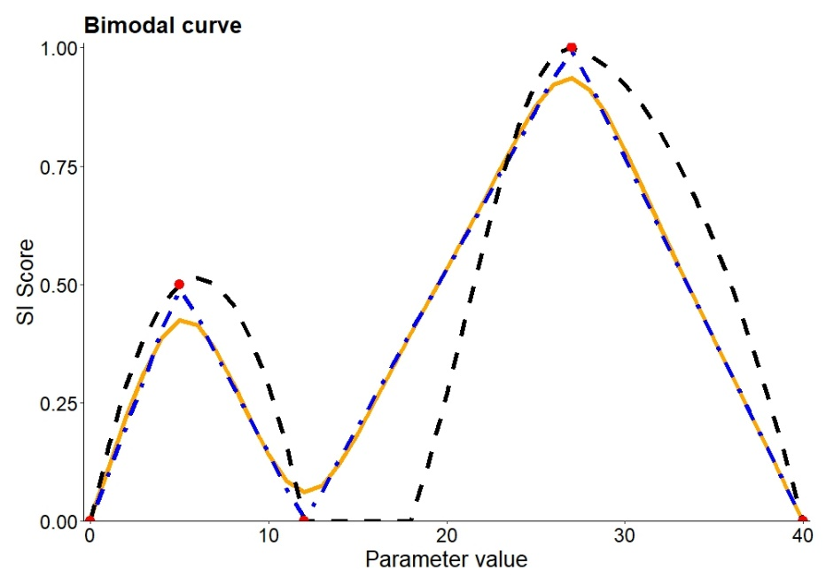*Bimodal* – A curve consisting of two peaks in suitability scores with lower suitability scores occurring at either end as well as between the two peaks. Parameter and score values for each peak can be specified by using the conditional option ‘bimodial_Yvalues’ when building the suitability curves. Parameter values are entered for 5 points within the desired range and the corresponding suitability scores (Y values) are also entered by the user.

|  |  |
| --- | --- |
| Parameter Value | Suitability Score |
| 0 | 0 |
| 5 | 0.5 |
| 12 | 0 |
| 27 | 1 |
| 40 | 0 |

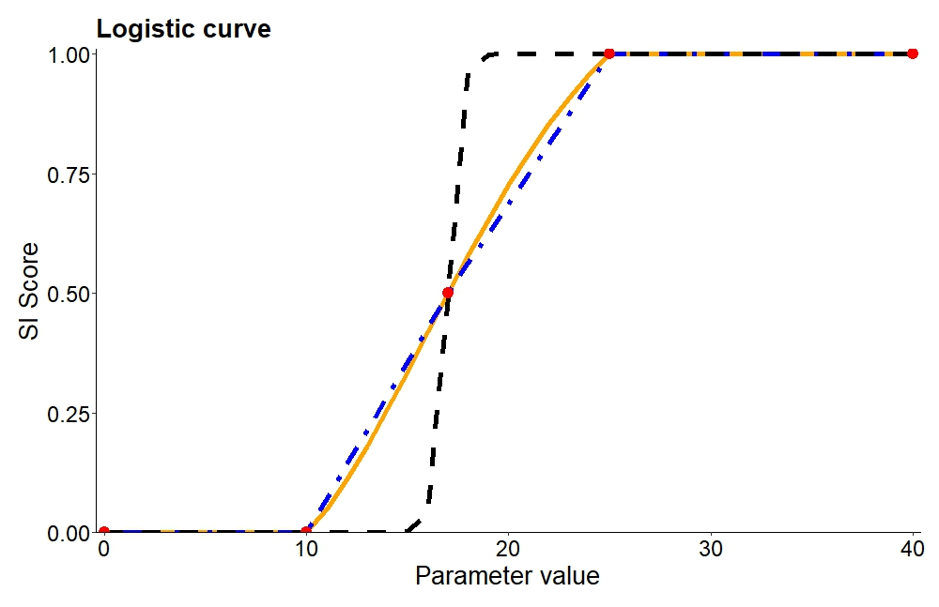*Logistic* – An S-shaped curve with an initial larger change in score value at lower parameter values shifting to a smaller change at higher parameter values with decreasing rates of change as the maximum values are reached. Parameter values are entered for 0, 0, 0.5, 1, and 1 to define the length of the parameter values at which the extreme score values are observed and to modify the rate of change over the curve.

|  |  |
| --- | --- |
| Parameter Value | Suitability Score |
| 0 | 0 |
| 10 | 0 |
| 17 | 0.5 |
| 25 | 1 |
| 40 | 1 |

|  |  |
| --- | --- |
| Parameter Value | Suitability Score |
| 40 | 0 |
| 35 | 1 |
| 27 | 0.5 |
| 25 | 0.05 |
| 0 | 0 |

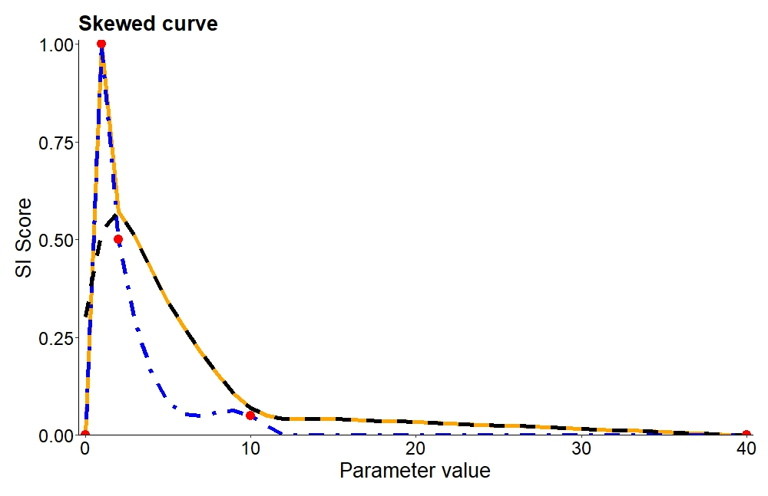*Skewed* – A curve with the highest suitability scores occurring within a small range of parameter values with a left or right tail of low suitability occurring within a large range of parameter values. Direction of skewedness is determined by order of parameter values with the first value entered being closest to the peak and the last value entered being within the tail of the curve. Parameter values are entered for 0, 1, 0.5. 0.05, and 0.

|  |  |
| --- | --- |
| Parameter Value | Suitability Score |
| 0 | 0 |
| 1 | 1 |
| 2 | 0.5 |
| 10 | 0.05 |
| 40 | 0 |

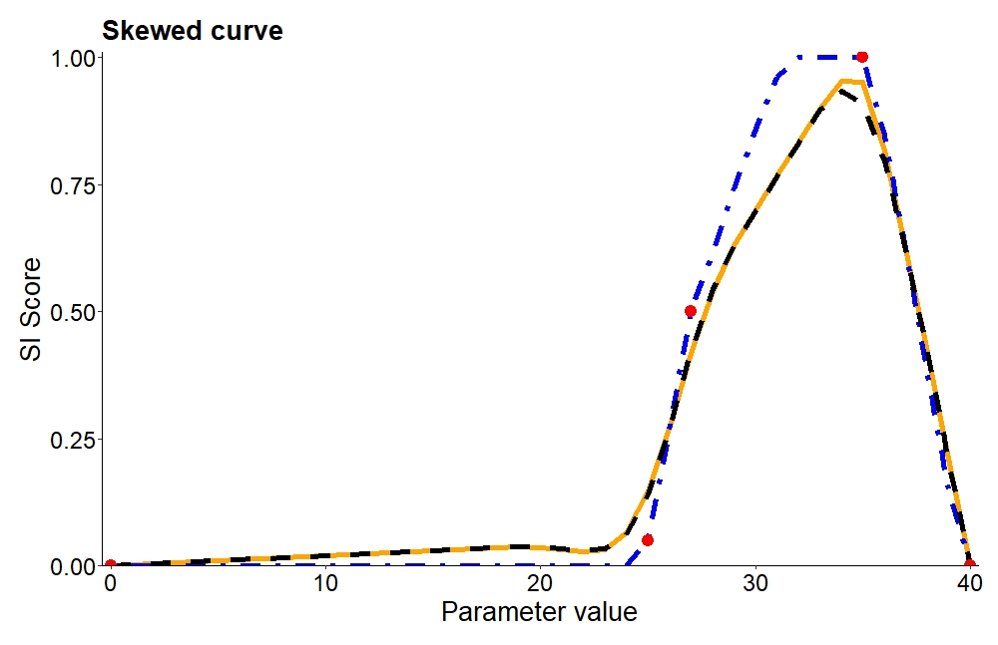

|  |  |
| --- | --- |
| Parameter Value | Suitability Score |
| 0 | 0 |
| 6 | 0 |
| 7 | 0.25 |
| 15 | 0.25 |
| 20 | 1 |
| 29 | 1 |
| 30 | 0.75 |
| 34 | 0.75 |
| 36 | 0 |
| 40 | 0 |

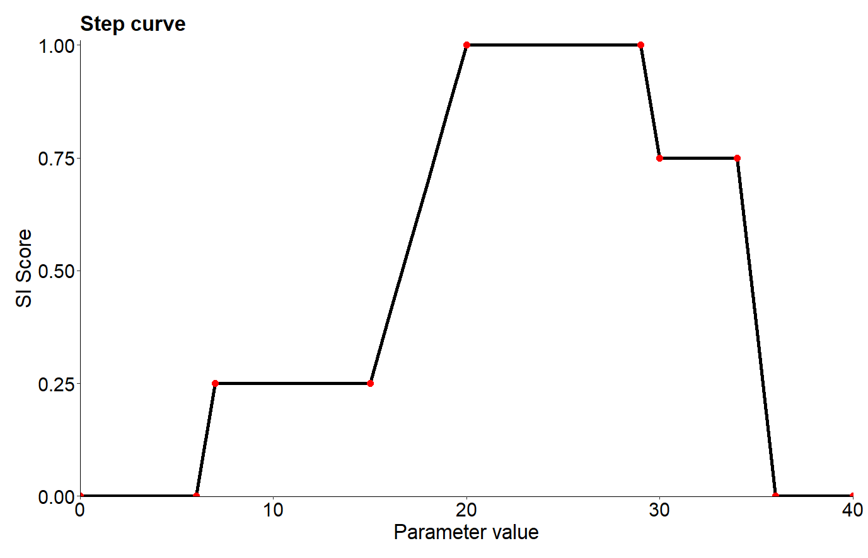*Step* – Stepped linear line. Parameter values are entered for each end point for step score. Suitability scores for each step are user specified [0-1] in step_values. A straight line is fit between each step to predict parameter suitability scores. Only a ‘hard’ fit can be applied to step curves. 0, 6, 7, 15, 20, 29, 30, 34, 36, 40

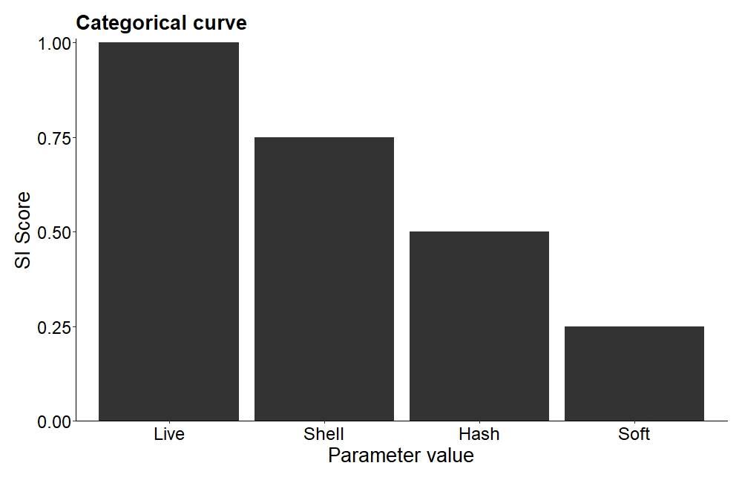*Categorical* – Application of suitability scores to categorical variables. User provides categorical factor levels as parameter values and their corresponding suitability scores as parameter limits.

|  |  |
| --- | --- |
| Parameter Value | Suitability Score |
| Live | 1 |
| Shell | 0.75 |
| Hash | 0.50 |
| Soft | 0.25 |